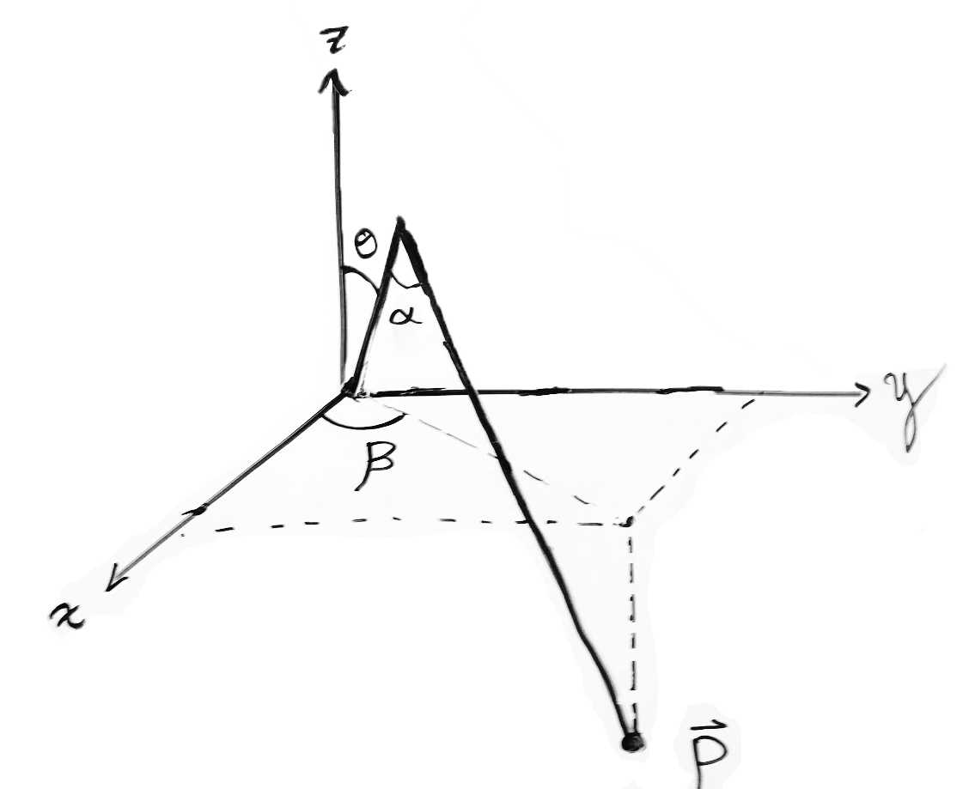

$$L_{2}$$

$$L_{1}$$

$$L_{1},L_{2}=const.$$

$$\vec{P}=\left\langle X,Y,\left.Z\right\rangle \right.$$

$$\left|\vec{P}\right|=\sqrt{X^{2}+Y^{2}+Z^{2}}$$

$$α=\cos^{-1}\left[\frac{{L_{1}}^{2}+{L_{2}}^{2}-{\left|\vec{P}\right|}^{2}}{2L_{1}L_{2}}\right]$$

$$θ=\frac{π}{2}-\cos^{-1}\left[\frac{{L_{1}}^{2}-{L_{2}}^{2}+{\left|\vec{P}\right|}^{2}}{2L_{1}\left|\vec{P}\right|}\right]{+\tan^{-1}\left[\frac{Z}{\sqrt{X^{2}+Y^{2}}}\right]}$$

$$β=\frac{π}{2}-\tan^{-1}\left[\frac{Y}{X}\right]$$

In the graph below: change $β$ to be defined as 0 at the y+ axis. Clockwise is positively increasing